Databricks Air Carrier On-Time Performance Analysis Project
Objective: Utilizing Databricks on AWS, this project takes in raw airline data from transportation site: https://www.transtats.bts.gov, cleans the data and presents a gold transformed layer for business view and further analysis.

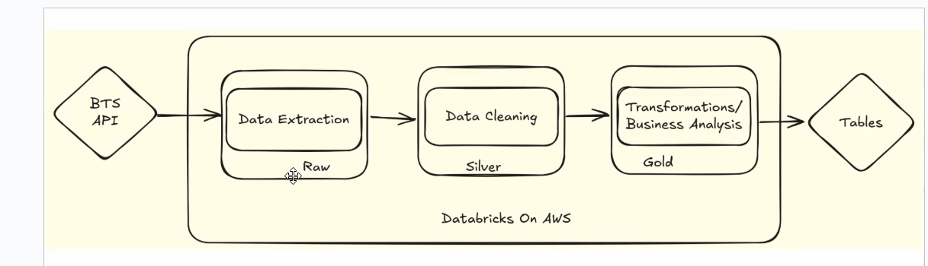

Process:
- Source extraction is the code to extract the data from the website and copy it into Databricks volume, (all data is from one month, e.g. January 2025)
*NOTE: The free version of Databricks did not allow me to download so code block 8 is commented out. I manually downloaded the data from site and copied into volume.
- In Data curation notebook, I am cleaning the data by selecting the columns to use, renaming to make sense, creating new column names, handling null values, and joining all the data together. This will be in one final table in the silver schema.
- Finally, in gold schema, the analysis notebook will aggregate the data to get average delays by airport, carrier, and airport. All the data is put into one table in gold schema for analysis.
- Orchestration job can be setup by changing API url to always use current year and month when running the job to get the latest data.

Databricks catalog view:
